THE REPUBLIC OF UGANDA
MUKONO DISTRICT STATE OF AFFAIRS ADDRESS TO COUNCIL
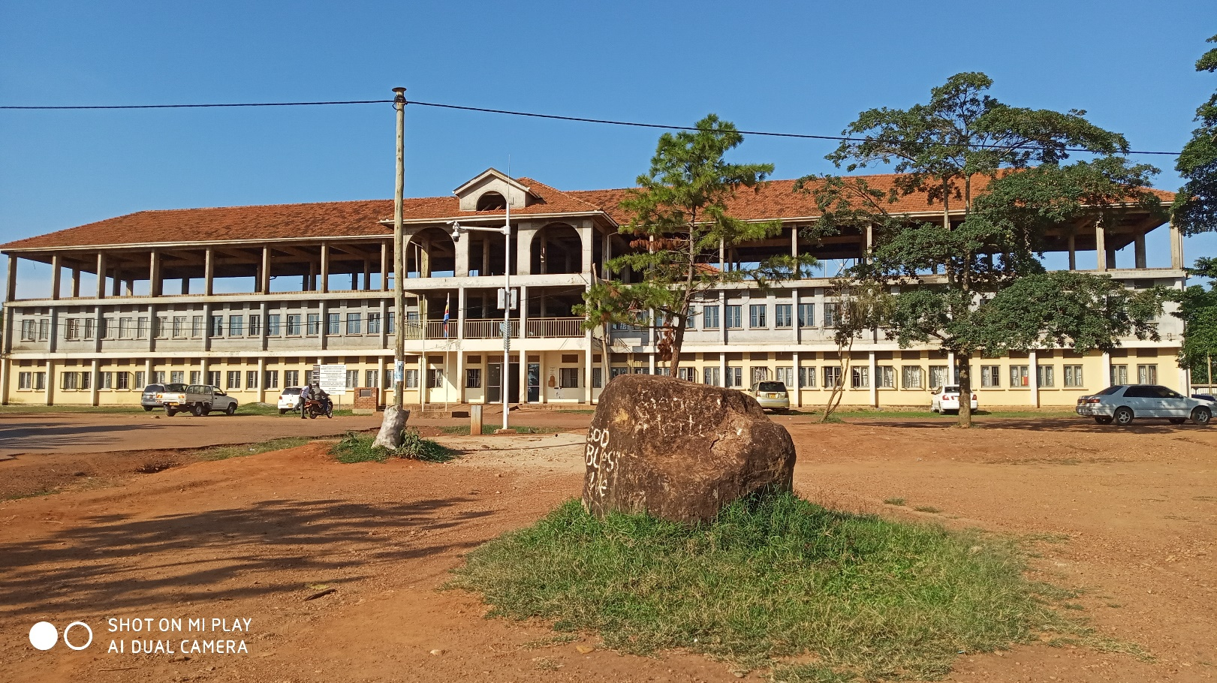

22nd October, 2019.

- Hon. Speaker Sir,
- Hon. Members of Parliament
- The RDC /Mukono
- Hon. Members of DEC /Council
- The Chief Administrative Officer / Mukono
- Heads of Departments
- Chairpersons and members of the Statutory Bodies
- Heads of Security
- Buganda Kingdom Officials
- Development partners
- Invited Guests
- Ladies and Gentlemen.
Greetings,
Mr. Speaker Sir, Section 13(5) of the LGA Cap 243 provides that the District Chairperson shall give an Annual Report to the Council on the state of Affairs of the District at least once a year. It is in fulfillment of that mandate that I present this District Annual Report for FY 2018/19 and some highlights of quarter one FY 2019/20.

On behalf of the District Executive, I wish to first of all congratulate Honorable members of this great council, the Speaker, Technical Staff, the Mayor of Mukono Municipal Council, the Resident District Commissioner (RDC) and his staff, Hon. Members of Parliament, Central Government Officers, Various Statutory Committees, Non-Governmental Organizations/Community Based Organizations(NGO/CBOs, Chairpersons of various political organizations and Media Fraternity operating in Mukono upon having ended FY 2018/19 and started FY 2019/20.

Despite enumerable challenges, we as a district made many achievements. This was possible because we worked as a team and had very limited internal conflicts. I wish to extend my gratitude to the entire political and technical leadership in the District for their efforts towards achieving the set developmental objectives for the District.

Mr Speaker Sir, I am happy to inform you and the entire house that the District launched the mass immunisation campaign of Polio and Measles-Rubella at Kisowera Primary School (P/S) in Nama Sub County on 16/10/2019. I thank the Ministry of Health for the support provided towards this campaign.

The District attained great achievements in Health, Education, Works, Administration, Water, Natural Resources, Community Based Services, Production, Council, Finance and Planning department. Bravo to all Heads of department and Chief Administrative Officer for ensuring that we serve the great people of Mukono.

In the special way I commend the Honorable councilors for the way they managed council business and political guidance that they provided to the technical team that led to attainment of great success in Financial Year 18/19

On behalf of the District Executive and Council, allow me express our heartfelt gratitude to Executive Directors for Non-Government Organizations operating in Mukono especially in Health, Education and Water Sectors. We thank you for investing financial resources in Mukono District

During Financial Year 2018/19, the District maintained its focus on achieving a “healthy, productive and prosperous population” by “providing coordinated services for poverty reduction and attainment of sustainable economic development”.

In Finance and Planning Sector, the major focus was on attainment of efficient and effective allocation and accountability for public funds so as to achieve sustainable social economic growth and development. At the end of financial year 18/19, this sector was able to collect locally raised revenue amounting to UGX 534,072,893 against the planned UGX 612,250,309 translating to a performance of 87.2%.
The overall district budget was UGX 42,229,863,466 and the actual collection performance was UGX 40,066,389,337 of which Central Government transfers was UGX 37,407,196,482 and transfer from other government units including donor fund amounted to UGX 2,125,119,962.
UGX 952,566,634 was transferred to the Treasury at the end of Financial Year 18/19. These funds were mainly for the construction of a Seed Secondary School in Kimenyedde Sub-county but the procurement process which was managed by central government had not been concluded by the end of FY 18/19 and construction of pit latrines in Koome Sub-county under Primary Health Care Development Grant.

In Health Sector, we mainly focused on provision of health quality services to the people of Mukono District through delivery of preventive, curative and rehabilitative health services

In the education sector, honorable members of this great council our direction aimed at developing a literate and democratic society that is able to sustain itself and support other sectors in development.

In works department, our main focus was at development and maintenance of district roads, providing technical guidance on maintenance of community roads and other infrastructures.

In Water sector, the major focus was promotion of development through sustainable use and equitable distribution of water resources in the District through provision of clean and safe accessible water to rural growth centers and promotion of sanitation through hygiene and sanitation facilities.

In Community Based Services our emphasis was on empowerment of Committees to harness their full potential through capacity enhancement, skills development, capacity financing and improving service gender responsiveness.

In Production and Marketing Sector, the focus was on increasing the rural house hold incomes and improve the food and nutrition security through implementation of Government programs like Operation Wealth Creation and implementation of the Four Acre model concept.

In Natural resources sector, we ensured sustainable management and utilization of district Natural resources.

Mr. Speaker Sir and honorable members allow me inform you a new department of Trade, Industry Local Economic Development was created effective 1st July 2019. Previously it was called Commercial Services under Production Department. This department represents the Ministry of Trade Industry and Cooperatives at the district level. It is mandated to focus on trade, local economic development and tourism, industry and cooperatives sectors in the district and to work together with the central government and the local government to deliver effective and customer centric services at the grassroots

Mr. Speaker Sir and honorable members allow me recognize the financial contribution made by the central government and development partners in the process of service delivery with the aim of achieving our vision as Mukono District.

This state of district address therefore presents in detail the attained achievements by different sectors in the district during FY 2018/19, priorities and key achievements attained in quarter one for FY 2019/20.

I beg to Move
FOR GOD AND MY COUNTRY
Signed by:

Andrew Ssenyonga
DISTRICT CHAIRPERSON/MUKONO DISTRICT

General Background
Mukono District lies in the Central region of Uganda, sharing borders with the District of Buikwe in the East, Kayunga along river Sezibwa in the North, Luwero in the North West, Kampala and Wakiso in South West, Tanzania, and Lake Victoria in the South with the Islands of Buvuma District. The District Headquarters is in Mukono municipality central Division, situated along Kampala-Jinja road (21Kms East of Kampala City).

Mukono central division serves as an Administrative and commercial center. Other urban centers include the five Town Councils namely Katosi, Kasawo, Namataba, Ntenjeru -kisoga and Nakifuma Nagalama Town Councils. Mukono District has a total area of 2,986.47kms², water bodies’ cover a total area of 1155.37km², which is about 38.7% of the district total area and 61.3% is the district land area.

It has a current population of 596,804 persons as per the UBOS 2014 Population Census Results, consisting of 289,757 males and 307,047 females, growing at a rate of 2.91% per year compared to the national growth rate of 3.0%. This is a relatively high growth rate of the population notwithstanding the fertility rate of about 6 children per woman throughout her child bearing age and at such a rate the population will double in the next 20 years.

  - Administrative Setup

Administratively, the district has 2 counties (Mukono and Nakifuma County), 11 sub counties, 5 Town Councils, 55 Parishes, 42 Wards and 607 Villages.

The district has 187 government and 225 Private/community Primary Schools. It also has 33 government and 39 private/community secondary schools. The Health Sector is distributed as seen below

Table 1 showing the distribution of Health Centers
Category | Government | NGO | Private | Total
1. Hospital | 0 | 2 | 0 | 2
2. Health Center IV | 2 | 1 | 0 | 3
3. Health Center III | 13 | 2 | 0 | 15
4. Health Center II | 24 | 11 | 0 | 35
TOTAL | 39 | 16 | 0 | 55

Mr. Speaker Sir, the district received communication from the central government that Mukono HC IV was upgraded to a Hospital status however we have not yet received transition guidelines. We will inform the house once the transition guidelines are communicated to us.

Demographic characteristics of the district

The district has a current projected population of 669,364 persons as per mid-2018, consisting of 324,986 males and 344,378 females, growing at a rate of 2.91% per year.
Table 1.0: District Population
Table 2: Showing the population indicators
S/N | Indicator | District ratio | National ratio
 | Population growth rate | 2.91% | 3.0%
 | Total fertility rate | About 6 children per woman | 5.4 children per woman
 | Population density | 326 persons per Sq.km | 123 persons per sq.km
 | Infant Mortality Rate/ 1000 Live births | 38 | 54

Table 3: Population distribution by age
Population age group | Percentage
Population aged Less than one Year | 3.1
Population aged 0-4 Years | 16.7
Population aged 0-8 Years | 29.2
Population aged 2-8 Years | 23.1
Population aged 2-17 Years | 46
Population aged 6-12 Years | 20
Population aged 6-15 Years | 27.7
Population aged 10-15 Years | 15.6
Population aged 10-17 Years | 20.2
Population aged 15-24 Years | 21
Population aged 16-64 Years | 49.6
Population aged 15-29 Years | 29.1
Population aged 2 Years and Over | 93.9
Population aged 10 Years and Over | 68.1
Population aged 15 Years and Over | 54.7
Population aged 18 Years and Over | 47.9
Population aged 20 Years and Over | 43.6
Population aged 65 Years and over | 2.9
Primary school age population (6-12 years) | 85.6%
Secondary school age population (13-18 years) | 43.6%
Source UBOS

2.0 DISTRICT VISION, MISSION STRATEGIC OBJECTIVES AND PRIORITIES.

District Vision: A prosperous, productive and healthy population.

District Mission: To provide coordinated services to the community by focusing on the national policies and local priorities

District Goal: Provision of timely and high-quality social services for sustainable development

The District Moto

“Clientele focus and satisfaction is our passion”

Objectives:

Identify and collect sufficient revenue to ensure that service delivery standards are met.

Contribute to the sustainable growth of the local economy through production.

Increase the level of basic education.

Improve the district infrastructure including roads, water source and building.

Provide accessible health services.

Increase access to safe water and sanitation.

Promote democratic and accountable local governance.

Improving management and administration at both higher and LLGs

Improving financial resources mobilization, financial management and financial services.

Increasing quantity and building the capacity of human resources.

Increasing stock and improving the quality of physical infrastructure.

Promoting gender quality and equity through gender responsiveness in various government programs.

Promoting and increasing ICT applications.

Facilitating access to critical agricultural production inputs.

Mainstream all cross-cutting issues in all development programs i.e. HIV/AIDS, Family planning and Environment.

Principles and Core values of the Organization

Mukono district upholds the following core values to guide its operations and in which members believe in and cherish.

Efficiency and Effectiveness. We shall achieve the intended results using available resources in line with the targets and performance standards sets.

Professionalism. We shall adhere to the respective professional codes of conduct and the general public service code of conduct.

Transparency and accountability. We shall be transparent and accountable for our decisions and action.

Confidentially. We shall not disclose without proper authority and information that has been obtained in the course of executing our official duties.

Compliance with set policies and standards. We shall comply with Government policies, legislation and standards.

Loyalty. We shall be committed to the policies and programs of sitting national and local government.

Team work. We shall cherish the spirit of team work in the execution of our duties.

Partnership. We shall engage our partners in designing, implementing, monitoring and evaluating the programs of the district.

Customer / client focus. We shall put the interest of our clients as the first priority and endeavor to meet their needs and expectations.

Integrity. We shall exhibit and shall not place ourselves under any financial obligations to individual or organizations what may compromise our professional behavior in the performance of their duties.

Optimum use of resources. We shall optimally use the available resources in the attainment of the set objectives and targets.

Responsiveness. We shall respond to the clients` needs effectively and efficiently whenever called upon.

Impartially and selflessness. We shall provide services to clients without discrimination on grounds of sex, rare color, religion, social or economic standing, political affiliations or disability by putting interest above personal interest.

3.0 STATE OF SERVICE DELIVERY/SECTORAL PERFORMANCE FOR FINANCIAL YEAR 2018/2019

Mr. Speaker Sir, below I present the state of service delivery in the district in line with our strategic objectives and priority areas mentioned above.

Mr. Speaker Sir, this report specifically focuses on the performance of the district sectors within the period under review;

3.1 FINANCE AND PLANNING SECTOR

Mandate. The Finance and Planning Department is mandated to ensure efficient and effective allocation and accountability for public funds so as to achieve sustainable social economic growth and development. The Budget performance for the 2018/2019 FY is summarized in two tables below with the first table (Table.4) showing budgeted revenue against actual releases received during the Financial Year, and the second table (table.5) showing Local Revenue performance. Mr. Speaker Sir, table six indicates the financial performance for quarter one.

3.1.1 Budget Performance for 2018/2019

Table 4: Budgeted Versus Actual releases for 2018/19 FY
RECEIPTS | Approved Budget  30th June 2019 | Actual  30th June 2019
Local Revenue | 612,250,309 | 534,072,893
Central Grant | 37,233,018,694 | 37,407,196,482
Transfers received from Other Government units | 2,946,809,772 | 2,125,119,962
Total receipts | 42,229,863,466 | 40,066,389,337
Transfer to Treasury |  | 952,566,634
 |  | 39,113,822,703

EXPENDITURE
Administration | 8,197,456,223 | 8,125,650,327
Finance | 1,036,351,000 | 481,704,784
Statutory Bodies | 819,036,000 | 763,730,620
Production | 2,014,432,259 | 2,009,682,259
Health | 5,468,859,984 | 4,359,380,404
Education | 20,983,031,000 | 20,975,640,789
Works | 1,829,312,000 | 1,701,768,489
Natural Resources | 180,190,000 | 176,082,051
Community Based Services | 580,510,000 | 373,617,109
Planning Unit | 1,041,298,000 | 83,567,142
Internal Audit | 79,387,000 | 78,809,146
TOTAL EXPENDITURE | 42,229,863,466 | 39,129,633,120

3.1.2 DETAILS OF LOCAL REVENUE
Table 5: Showing Local Revenue performance for 2018/19 FY
RECEIPTS | APPROVED BUDGET(SHS) | ACTUAL (SHS)
Local Services Tax | 165,850,309 | 123,280,302
Land fees | 46,500,000 | 50,304,400
Business Licenses | 12,000,000 | 5,872,600
Hotel Tax | 4,500,000 | 4,235,342
Other general taxes on goods and services | 320,900,000 | 350,380,249
Miscellaneous and unidentified revenue | 62,500,000 | 0
Total revenue | 612,250,309 | 534,072,893

From the above table, we budgeted to collect Shs 612,250,309/= as Local revenue in 2018/19 financial year and Ushs 534,072,893/= has so far been collected giving a performance of 87.2%.

Table 6. The financial performance for quarter one FY 2019/20
 | DETAILS | AMOUNT
A: | GOVERNMENT GRANTS
01 | Wage | 6,250,270,106
02 | Pension | 793,866,771
03 | Gratuity | 342,905,551
04 | Pension and Gratuity Arrears | 367,260,976
05 | Salary Arrears | 8,860,715
06 | Non-Wage Recurrent Grant | 1,739,816,636
 | Total Grants | 10,801,419,083
B: | TRANSFERS FROM OTHER GOVERNMENT UNITS
01 | Road Fund | 223,176,864
02 | Other Government Transfers (MUWRP) | 123,010,000
03 | Ministry of Health- Measles campaigns | 316,930,700
 | Total transfers from other Govt Units | 663,117,564
C: | Donor Fund | 42,420,000
 | Total Donor Fund | 42,420,000
D: | Local revenue | 241,327,184
 | Total Local Revenue | 241,327,184
 | TOTAL REVENUE | 11,748,283,831

3.1.3 Department achievements in 2018/19 FY
- The department managed to coordinate 12 District Technical Planning Committee meetings
- Provided back up support to Lower local Governments and departments in budget preparation and reporting using PBS
- The department continued with the traditional functions of monitoring of all Lower Local Government programmes
- Coordinated the preparation of the Budget Frame Work Paper and National performance assessment spearheaded by OPM
- Under District Discretionary Equalization Grant, payments were made for the Construction of Classroom block at Kayini Kamyokya in Seeta Namuganga S/C and five Stance VIP latrine at Maziba Primary School in Ntenjeru S/C.
- Made payments for the OPD at Kitovu HCIII in Kasawo Town Council which was constructed in a phased manner.
- Coordinated Budget Conference for financial year 2019/2020 which was successfully held in the month of November.
- Prepared and submitted four Quarterly budget performance reports to the Chief Administrative Officer for the final submission to the Office of the Prime Minister and Ministry of Finance, planning and economic Development.

    - Priorities for finance and Planning department in FY 19/20

- Enforce proper management and accountability of the financial resources of the District local Government by ensuring that the resources obtained/received are effectively allocated and efficiently utilized to enable the District achieve its set goals.
- To provide proper financial management and accountability for financial resources of the District Local council through intensive monitoring, mentoring and supervision.
- Enforcing adherence to financial practices, Regulations, Policies and Professional practices in all financial transactions with in the District.
- Backstopping & monitoring activities in LLGs
- Preparation of Annual Budgets and work plans
- Enhance Local Revenue mobilization and collection
- Preparation of Quarterly reports and submission to line ministries/ authorities
- Mentor lower local governments on proper financial management practices and accountability
- Enforce realistic Budgeting, budgetary control and planning.
- Ensuring proper books of accounts maintained in LLGs
- Updating the District Business Register
- Promote timely accountability of the public funds
- Coordinating 2018/19 FY Internal Assessment exercise organized by Office of the Prime Minister
- Carrying out technical backstopping to LLGs in the areas of development planning and budgeting to ensure compliance with the set laws and guidelines.
- Preparing and submission of all Budget performance reports (Q1, Q2, and Q3and Q4) to the office of CAO
- Provision of Support to HODs and LLGs in preparation of Budget Framework Paper and Final Performance Contract for FY 2020/21
- Coordinating the formulation of the third 5 year Development plan.

    - Achievements registered during Quarter one for FY 2019/20
- Preparation and Submission of final Accounts for 2018/19 FY
- Transfer of funds to LLGS and Health Units and Schools
- Payment of staff salaries, Pension and Gratuity for month of July, August and Sept, 2019
- Transfer of sub County and Town Council Local Revenues for first quarter 2019/20 FY
- Property valuation exercise is still on going
- Payment of Pension and Gratuity Arrears for 2019/20 FY
- Preparation of Accounting warrants for first quarter 2019/20FY
- Back up support to LLGs in preparation of final Accounts for 2018/19 FY
- Coordinating three DTPC meetings
- Preparation and Submission of final Budget for 2019/20 FY

    - Department Challenges.

- Delayed processing of Electronic fund transfers (EFTs)
- The department lacks a vehicle to support revenue mobilization
- Lack of enforcement team to boost revenue collection.

ADMISTRATION DEPARTMENT

Mandate. The Administration department has a mandate under the stewardship of the Chief Administrative Officer of heading the District public service and provides strategic leadership. During FY 2018/2019, the department registered the following achievements:-
- During Financial Year 18/19, the department ensured timely payment of salaries, pension and gratuity.
- The Department coordinated, supervised and monitored government programs in relation to enhancement of service delivery in the district in all departments like Production, Health, Education and Works.
- Complied and submitted quarterly budget performance reports to line Ministries i.e. Ministry of Finance Planning and Economic Development.
- The department ensured that public property and resources are properly managed and safe guarded. In pursuant to this requirement, a Board of survey report for Financial Year 2018/19 was produced and submitted to the office of Accountant General.

- Administration created harmony and effective coordination of head of departments, lower council staff, and political leaders.

- The department ensured that value for money is attained for public funds through enforcement of timely accountability for public funds.

- The department supervised and monitored the implementation of performance agreement and performance appraisal for staff and assessment for effective service delivery.

INTERNAL AUDIT

Mandate. The Internal Audit has a mandate to promote an independent, objective assurance and consulting audit function designed to add value and improve Council’s operations for proper and effective delivery of public service: During Financial Year 18/19 ,Internal Audit registered the following achievements.

- Prepared and submitted internal audit quarterly reports to the relevant offices such as District Speaker, Office of CAO etc.
- Conducted a risk assessment of Councils operations and made recommendations to management on risk mitigation measures
- Reviewed the financial and accounting systems of operations in the district and made recommendations regarding their adequacy, effectiveness and compliance to relevant laws and regulations
- Witnessed delivery of farm inputs under Operation Wealth Creation to ensure that deliveries were properly ordered, certified by subject matter specialists and actually distributed to the intended beneficiaries
- Monitored on-going and implemented projects and made recommendations regarding implementation status, quality of work and compliance to specifications

3.4 EDUCATION DEPARTMENT
Mandate. The Education department has a mandate of developing a literate and democratic society that is able to sustain itself and support other sectors in development. At the end of Financial Year 18/19, the department had success as indicated below:
- Ensured timely payment of salaries to teachers at primary and secondary levels
- Carried out monitoring and inspection of both ECD centers, primary schools (government and private) secondary schools (government and private)
- Carried out construction of a two in one classroom block with an office and store at St Joseph Ssozi P/S in Mpatta S/C
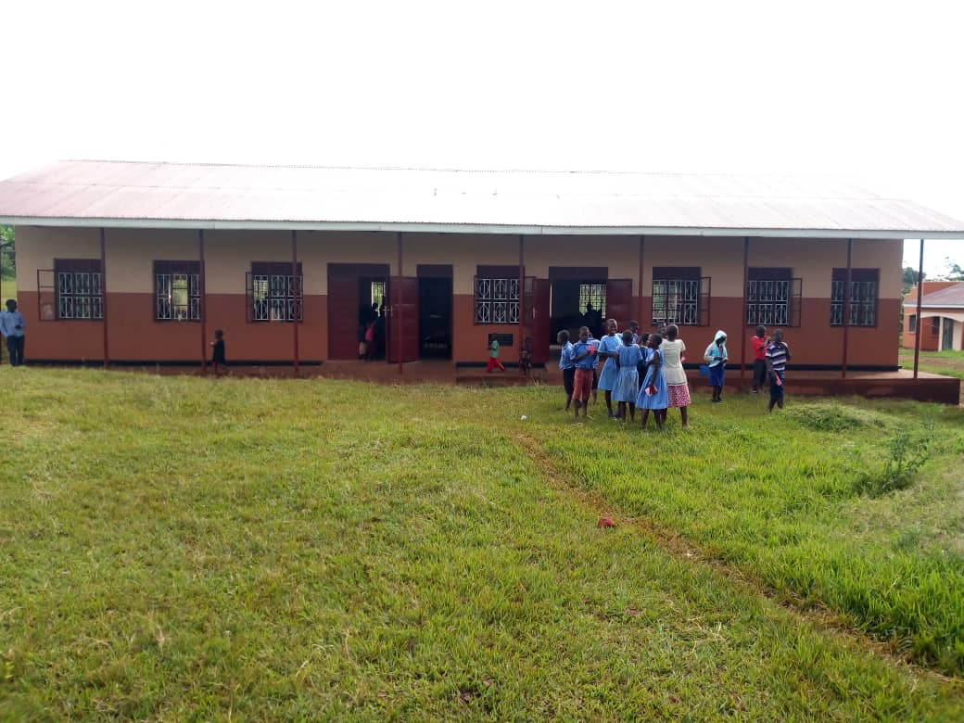

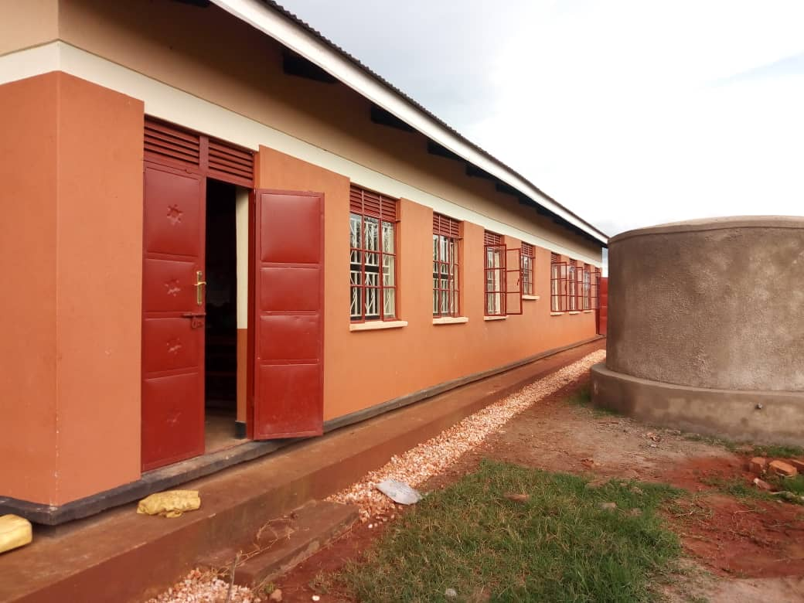

- Procured a double cabin pick up for education department under SFG for FY 2018/19.
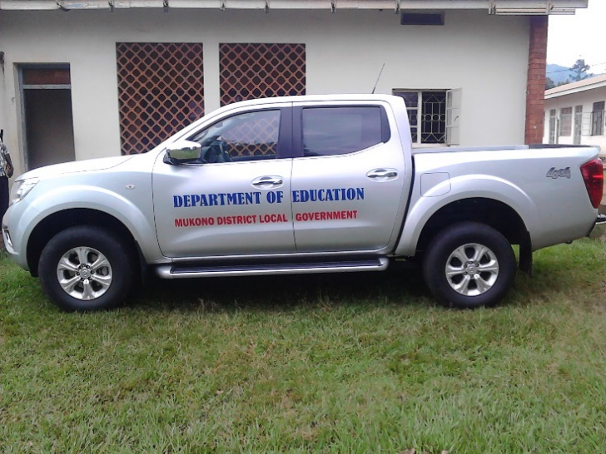

- Carried out construction of 8 in one Staff house, Kitchen and toilet at Bunyiri Moslem Primary school in Kyampisi Sub County which was completed and waiting for official commissioning
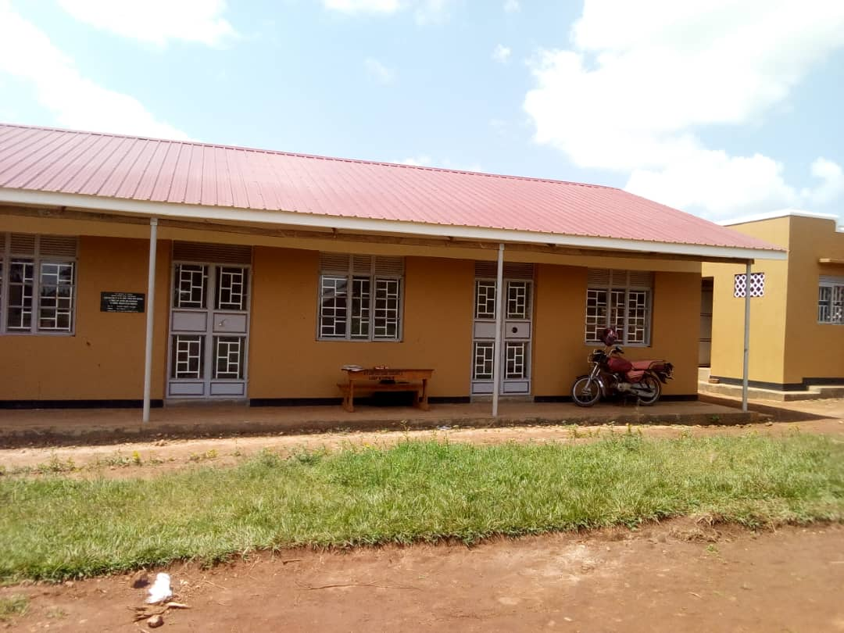
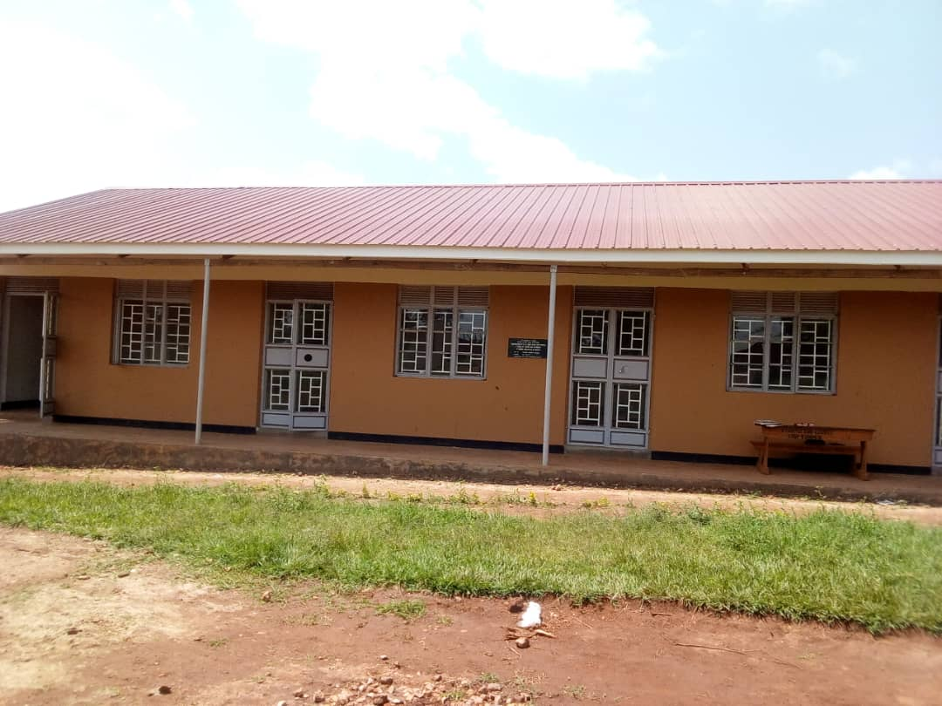

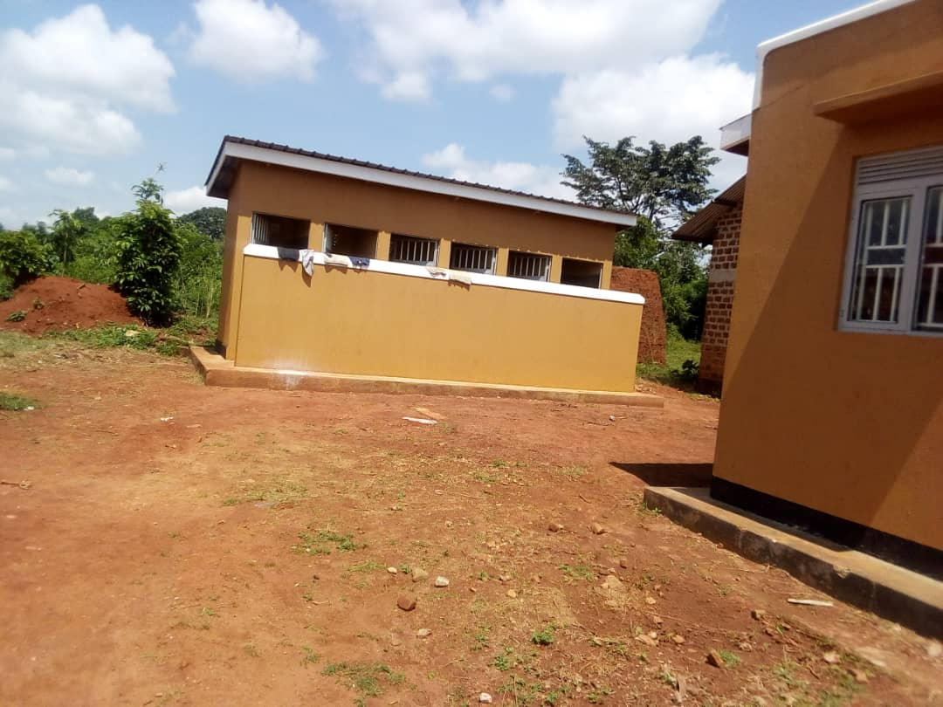
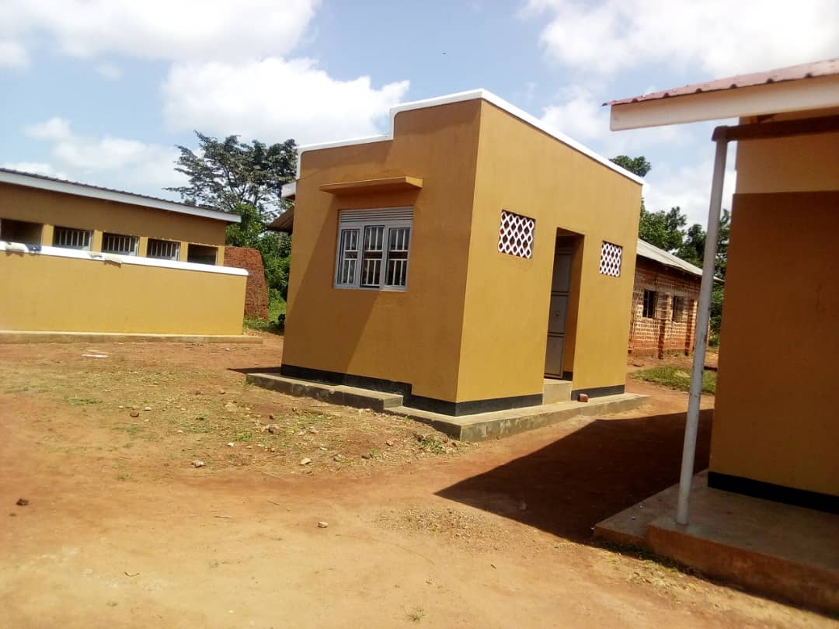

- Payment of UPE and USE grants to all government and government aided primary and secondary schools.
- UPE- 863,994,390/=
- USE- 2,653,101,657/=
Successfully conducted PLE 2018 and the results were as follows:
- Total candidates = 11801
- Division i = 1809
- Division ii = 5280
- Division iii = 2219
- Division iv = 1557
- Division v = 890

3.4.1 Priorities for Education department in FY 19/20

Table 6: Proposed projects to be undertaken Fy. 2019-2020
Project | Location | Estimated Cost
Construction of a Seed Secondary School | Kimenyedde S/C  (Ndwaddemutwe) | 1,095,814,000/=
Classroom block with a 4 stance VIP latrine | Namulaba P/S in Nagojje Subcounty | 200,583,840/=
Construction of a 5 stance lined VIP latrine | - Koome C/U  - Koome Buyana  - Kayini C/U  - Seeta Nazigo C/U | 48,381,092/=  48,381,092/=  30,967,218/=  30,967,218/=

3.4.2 The achievements that have been registered for quarter one FY 2019/20
- The department managed to disburse UPE and USE to all schools
UPE = 377,290,000/=
USE = 652,950,000/=

- Mr. Speaker Sir, the Ministry of Education and Sports distributed text books to all Government Aided and Government Schools (Primary)
- P.1- P.7 ( Fountain Published English )
- P.1-P.3( Baroque publishers (Math)
- P.4-P.7 (Mk Publishers (Math)
- The Ministry has also supplied furniture to World Bank constructed schools under (UTSEP) Uganda Teacher and School effectiveness project (Mother Kevin Namukupa and Namutambi Primary Schools).

Table 7: Showing the distribution of furniture to World Bank schools under UTSEP
School | Office tables with drawers | Class Teacher | Class tables | 3 Seater desks |  |  |  |  |  |  | Total | Staff room tables | Chairs
 |  |  |  | P1 | P2 | P3 | P4 | P5 | P6 | P7
Mother Kevin Namukupa | 2 | 5 | 5 | 18 | 18 | 18 | 18 | 18 | 0 | 0 | 90 | 4 | 16
Namutambi | 2 | 7 | 7 | 18 | 18 | 18 | 18 | 18 | 18 | 18 | 126 | 4 | 16

- Co-curricular Activities
Mr. Speaker Sir, the education department organized various Co- curricular activities that included.
Ball games: - The activities were organized starting at school level, Sub- Zone, Zone then to District Level. The District facilitated a team of 16 members headed by the Sports Officer, Ms. Nanziri Proscovia and Mr. Ssemanda Joseph, the Chairman Sports committee to participate in the National Competitions that were held in Iganga Municipality.
We participated in the following disciplines:-
Football under 12 (boys)
Net ball under 12 (Girls)
Net ball under 12 (Boys)
Hand ball under 12 (Boys), under 12 girls and under 14 girls
Volley ball – under 12, Girls & under 14 girls
- Goal ball – SNE (junior boys and girls senior boys and girls.
- Show down – junior boys & girls, intermediate boys and girls

Mr. Speaker Sir, allow me to inform members that as Mukono District we got trophies and medals in the following categories:-
- Volley ball under 12 girls .We were in 3rd position and obtained 10 bronze medals
- Handball under 12 girls. We were in 2nd position and obtained 10 medals
- Hand ball under 14 girls. We were in 3rd position and obtained 10 bronze medals
- Goal ball – Junior Boys. We were in 2nd position and obtained 4 silver medals

- The department carried out inspection of 210 primary schools and 20 secondary schools in the district for quarter one.

Mr. Speaker Sir, my gratitude goes to Katosi Women group, Reach the Children and Katosi Inter Community Development Alliance for the infrastructural improvements undertaken in our schools such as Kabanga Muslim.

3.5 HEALTH DEPARTMENT

Mandate. The Health department is mandated to provide the highest possible level of health services to all people in Mukono district through delivery of preventive, curative, palliative and rehabilitative health services. During Financial Year 2018/2019, Health department registered the following achievements:

3.5.1 The Achievements undertaken for FY 2018/19
- Increased utilization of health clinics due to improved supply of Drugs and health supplies procured and delivered by National Medical Stores
- Implementation of immunization programme targeting 11 childhood killer diseases whereby over 90% coverage was achieved. This has led to nil childhood killer disease outbreaks and reduction of infant mortality rate.
- Improved safe motherhood programs contributed by increased antenatal care services with performance coverage of 98% for antenatal care 1st visit. This high coverage has been contributed by the provision of free bed nets to mothers who attend antenatal care visits.
- Increased maternity deliveries in health units registering 59% performance. This has been contributed by regular availability of medicines , medical equipment and reduction of staff absenteeism
- Construction of 2 blocks of VIP latrines at Ddamba health centre II (Koome Sub County). This project has addressed lack of sanitary facilities at Ddamba OPD block and at the staff quarters. The project was funded by PHC grant.

Construction of a two Units Two Stance VIP Latrines with Urinals and Bathrooms at Ddamba Health Centre II Koome Islands in FY 2018/19
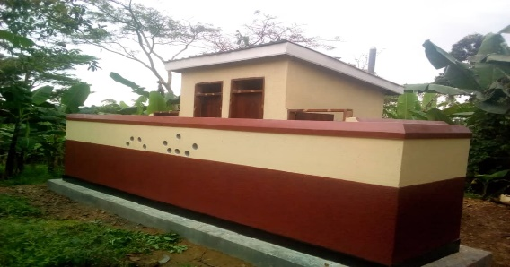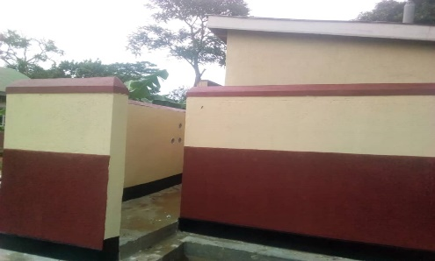

- Construction of a new OPD block at Kasawo health centre III funded out of the district DDEG grant. 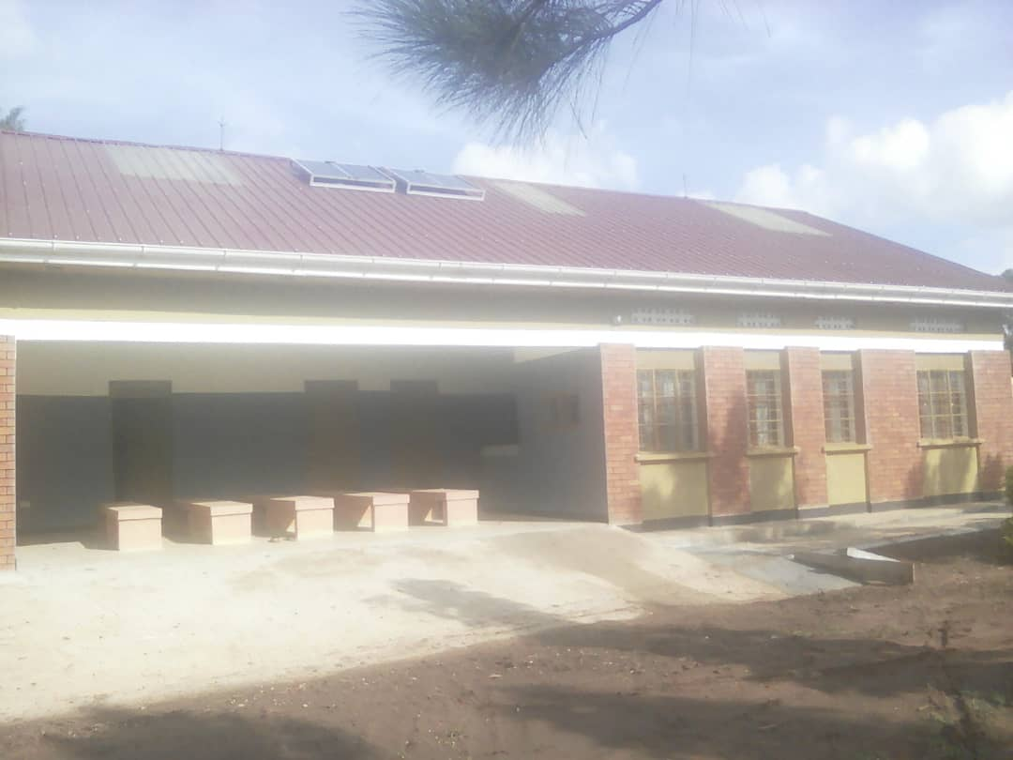
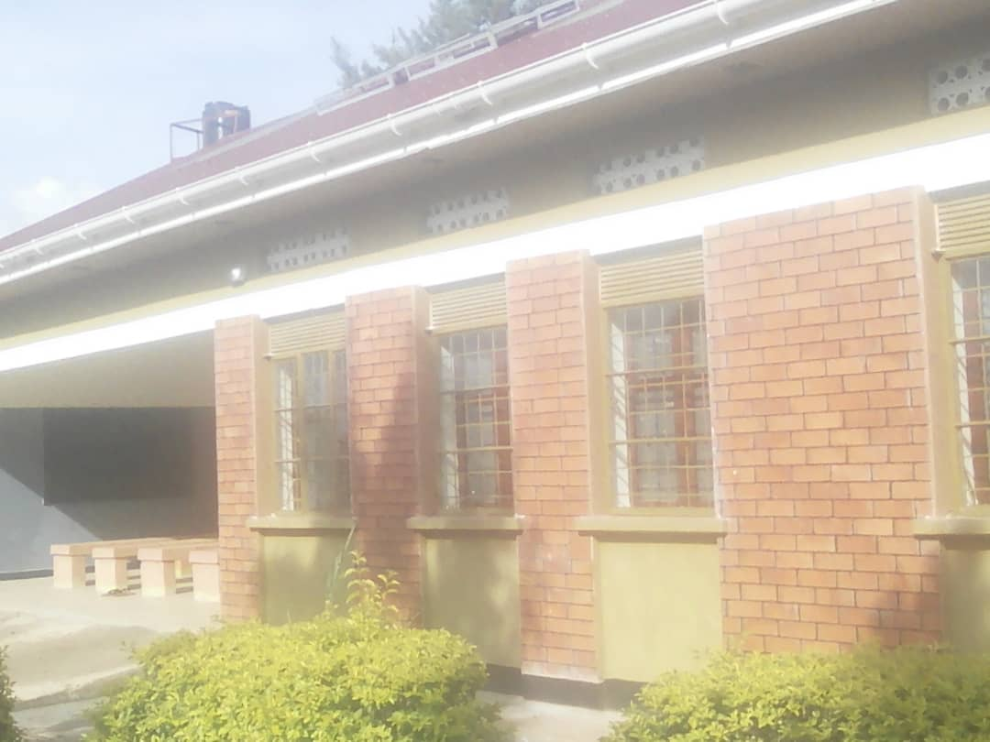
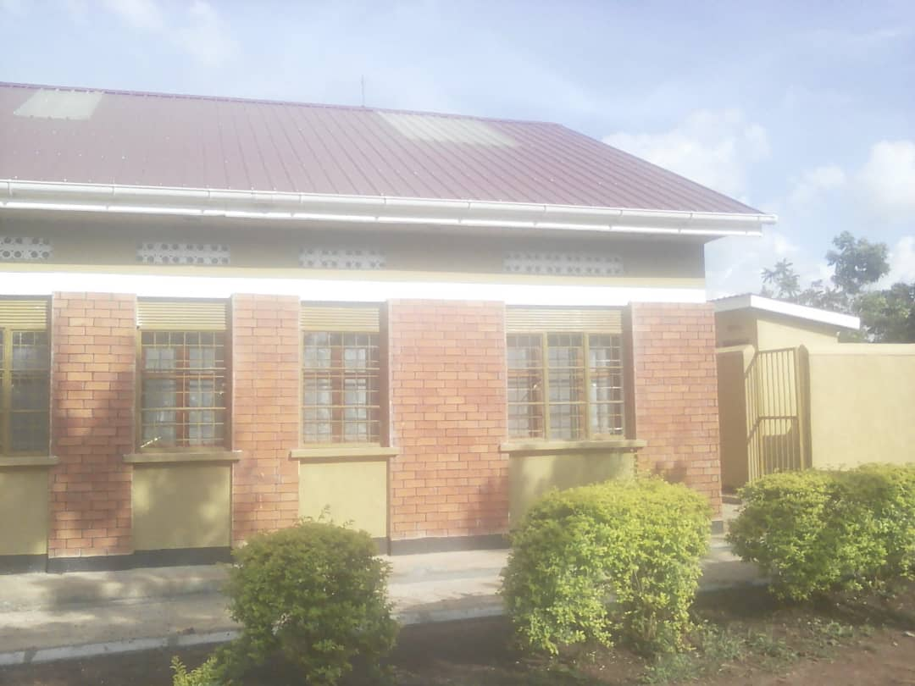
- A toilet constructed at Kitovu HC III in Kasawo Town Council
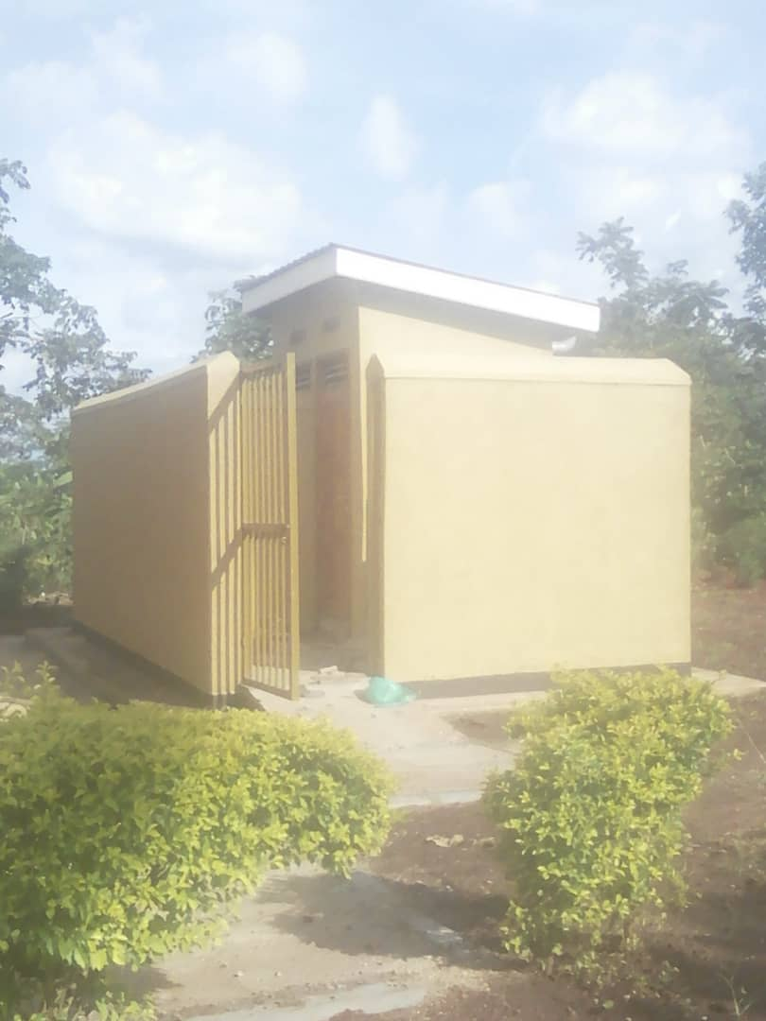
- Renovated the maternity ward at Kyampisi HC III using funds from Result Based Financing
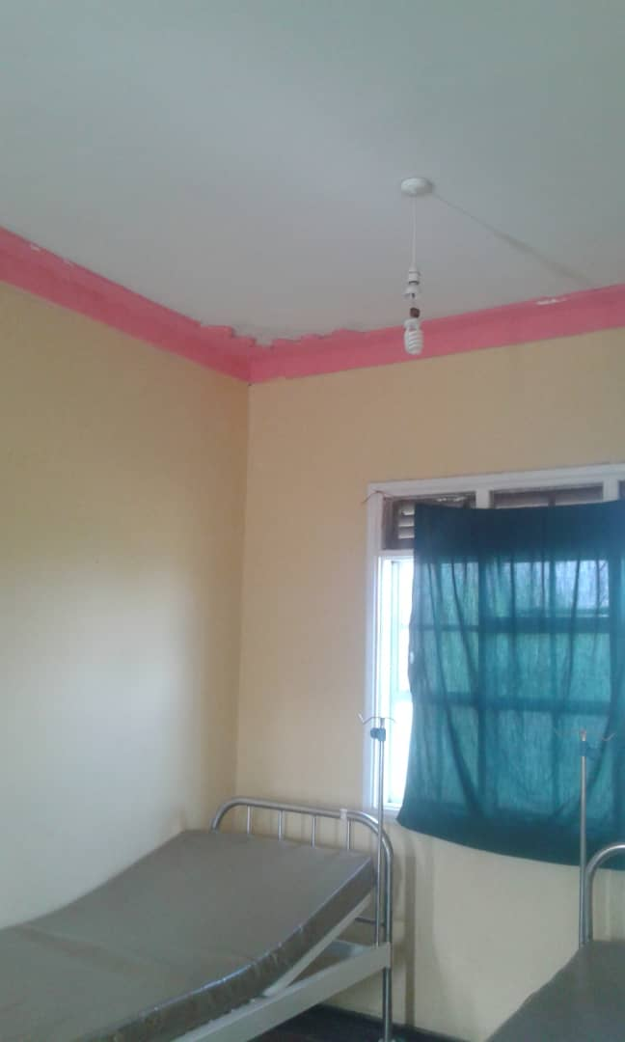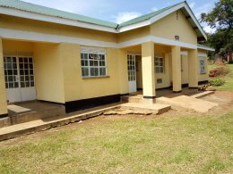

- Construction of an antenatal care waiting shade at Nakifuma HC III funded by RBF
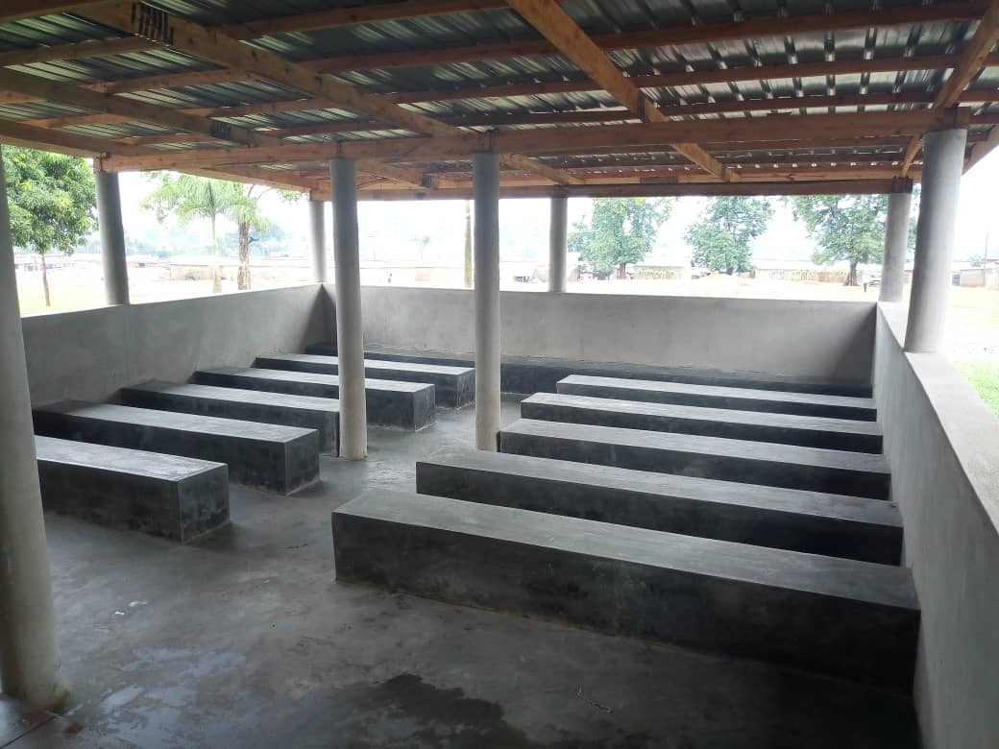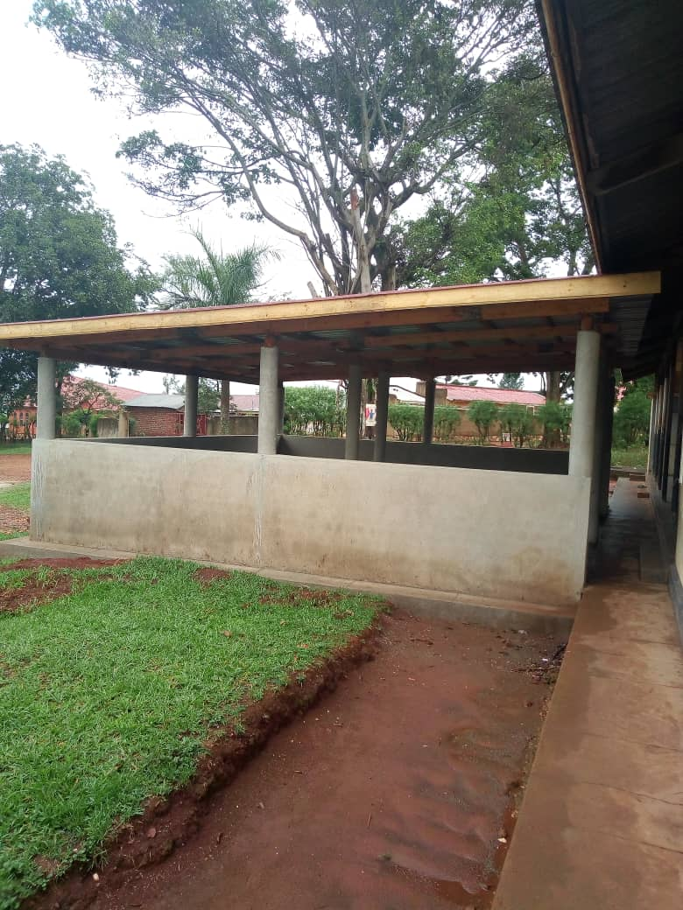

3.5.1 The Sector Priorities for FY 2019/20
- Strengthening routine immunization targeting Sub counties having Low coverage and high dropout rates
- Malaria control focusing on treatment and bed net coordination.
- Scaling up Youth Friendly Services in Health center IIIs and IVs targeting reproductive health.

- Construction of antenatal care waiting shelter at Kojja H/C IV, Nakifuma H/C III block and Koome H/C III

3.5.2 The activities undertaken during the first quarter for financial year 2019-2020
- Paid monthly salary to 387 heath workers for three months in quarter one FY 19/20.
- Held one review meeting at District level, Health Sub District Level.
- Held one planning meeting with health unit management committee and joint monitoring of health facilities.
- Provided support supervision of health programmes by the DHT (HRH and programs)
- Transferred UGX 250,000,000 to Mukono Municipality for upgrading of Mukono health centre IV.
- Transferred UGX 91,727,057 (quarterly 22931764.25) to Joint Medical Store for procurement of EMHS by PNFP health units.
- On Going Construction of a 6-in-1 Staff Quarters At Koome Hc III Funded By MUWRP
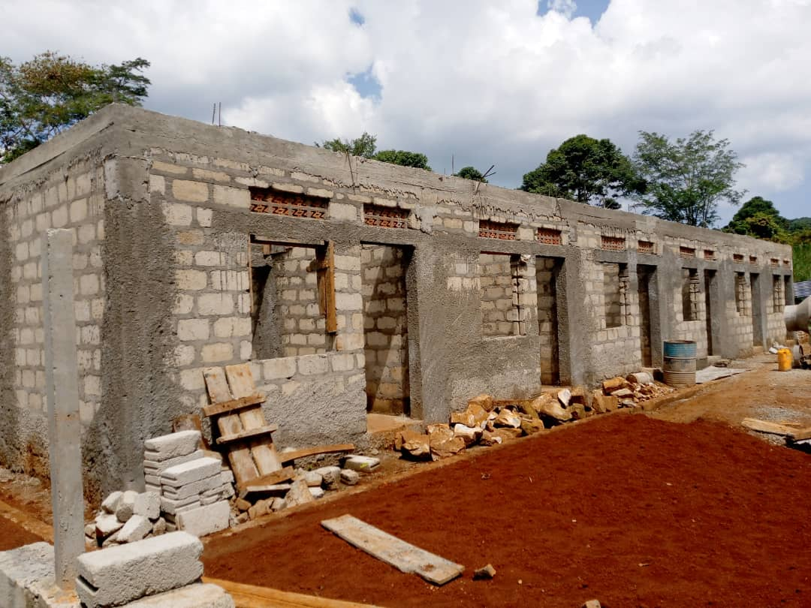
- Carried out training of Health workers from private health units in malaria control funded by PACE.
- Commissioned Makukuba Aid post in Nabbale sub-county.
- Completed functionalization of new health facility taken on by Ministry of health. These are Kasenge HC II and Myende HC II.

3.5.3 Department Challenges
- Inadequate ambulance services for the district
- Inadequate Health Facility diagnostic equipment
- Inadequate Health Facility on Koome Island
- Dilapidated Health Facility buildings
- Lack of Health Facility land titles

WORKS DEPARTMENT

Mandate. The Works department has a mandate of developing and consolidating the infrastructure in the district. During Financial Year 2018/2019, Works department registered the following achievements:
Carried out Mechanized maintenance of the following Roads:
- Kiteredde – Nkoko - Kabimbiri road, 12.00km in Kasawo/Ntunda local Governments
- Ntenjeru - Bule road, 18.53km in Ntenjeru/Mpatta local Governments
- Nsanja - Mpunge road, 20.00km in in Ntenjeru/Mpunge local Governments
- Bulanga - Kasokoso road, 14.40km in Nagojje local government
- Takajunge - Nama road, 04.10km in Nama local government.
- Takajunge - Nsambwe road, 02.58km in Nama local government
- Namanooga – Gimbi - Nacyeke road, 19.81km in Seeta Namuganga local government.
- Routine manual maintenance of 471.15 km of District roads for the 4 quarters.
- Casting of 150. concrete culvert rings for the four quarters,
- Installation of 40 lines of culverts for the Four Quarters in all district roads of which 2 lines of 1500mm diameter installed at Sezibwa River and along Kabimbiri-Nkooko-Kyabazala road

Mr. Speaker Sir, allow me to inform the house that the Mechanized maintenance of Kibanga – Lwazimiluli - Ngaga road, 12.00km is on hold as the department is still waiting for the ferry services to transport the equipment to Koome Sub County.

3.6.1 Department Priorities for 2019/20 FY
- Completion of the first floor of administration block
- Routine manual maintenance of roads 471.15km
- Mechanized maintenance of roads 106.52km
- Making 224 pieces of Culverts
- Installation of 32 lines of culverts
- Equipment repair & maintenance of all machines

3.6.2 Department Challenges
- Lack of a supervision vehicle, pickup.
- Lack of Axle load control mechanisms on our roads, whereby overloaded trucks have continued to abuse/destroy our roads, and
- Inadequate security for the equipment and plants at the works yard.

WATER SECTOR

Mandate. The Water sector is mandated to provide clean, safe and accessible water to rural communities and rural growth centers. During Financial Year 2018/2019, Water sector registered the following achievements:
- Drilled one production borehole for Nagojje Solar powered water supply system
- Completed phase one construction of Mayangayanga Rural Growth Centre piped water supply system with a pump house, main transmission line and reservoir tank.
- Rehabilitated 37 community boreholes in the following Lower Local Governments Kyampisi, Nama, Nagojje, Mpunge, Ntenjeru, Kasawo, and Seeta Namuganga
- Conducted Water Quality tests on 250 point potential water points across the district.
- Conducted sub counties advocacy meetings.
- Held hygiene and sanitation campaigns in 19 selected villages in Nama and Kimenyedde Sub-counties.
- Held four quarterly District Water and sanitation Coordination Committee meetings for FY 18/19.

3.7.1 Sector Priorities for 2019/20 FY
- Drilling of 15 new hand pumps in very remote and water stressed areas
- Rehabilitation of 35 hand pumps under major repairs
- Construction and completion of phase II&III of Mayangayanga Water Supply
- Extension of Koome GFS and construction of reservoirs
- Conducting community mobilization activities for water across the District
- Conducting hygiene and sanitation promotional activities

3.7.2 Achievements in Quarter one for 2019/20 FY
- Conducted Hydrogeological surveys for deep boreholes.
- Pipe laying for Mayangayanga-Kawongo, Mayangayanga-Kasana, Mayangayanga-Nanga water supply system was ongoing.
- Started on the process of procurement for expansion of Koome GFS and construction of reservoirs.
- Carried out assessment of 50 hand pumps for possible major repairs.

3.7.3 Sector Challenges
- Lack of enough funds to rehabilitate all the boreholes in the lower local governments
- The Sector lacks a vehicle to support supervision and monitoring of filed activities

PRODUCTION DEPARTMENT

Mandate. The Production department has a mandate of transforming the subsistence Agricultural sector to a commercial and self-sustaining sector. During Financial Year 2018/2019, Production department registered the following achievements:
- Acquired one new brand double cabin and 8 new motorcycles from Central government. The Motor cycles were distributed to the following LLGs: Koome, Nakisunga, Kyampisi, Nama, Seeta Namuganga, Kimenyedde, Ntunda, and Ntenjeru Town Council
- Selected priority commodities value chains for prioritization and commercialization; these are Coffee, Banana, Dairy, Piggery, Poultry, Silver fish and Nile Perch in all Sub counties
- Established and launched 4 acre model farm in 6 Lower local : Nama, Koome, Ntunda, Kimenyedde, Ntenjeru and Kyampisi
- Controlled and managed major pests and disease in the District (Fall army worm and coffee twig borer)
- 5 Plant Clinic sessions conducted, farmers advised on pests and disease identification
- 5 demo sites set up on control of FAW in 5 Farmer Field School groups and activities monitored ,6 other FFS groups maintained in 12 Sub counties
- Facilitated District political and technical leaders to supervise and monitor all Production activities in the District and Sub-counties in all 13 Sub counties
- Inspected Crop nurseries and registered 176 crop nurseries in Nakisunga, Kyampisi, Nakifuma-Nagalama, Ntenjeru, Nama, Ntunda, Kimenyedde, Kasawo and Seeta Namuganga.
- Carried out training of 2105 Crop farmers, 518 Livestock farmers, 52 fish farmers and 80 apiary farmers in production and management l lower local governments.
- Promoted 3 Priority commodity enterprises along value chain (Dairy, Piggery and Poultry) 5000 dogs were vaccinated against rabies in 13 sub-counties between March and June 2019.

3.8.1 Department Priorities for 2019/20 FY
- Establishment and maintenance of plant clinics
- Establishment and maintenance of farmer field schools
- Crop Pest and disease surveillance, diagnosis and control.
- Livestock pest and disease surveillance, diagnosis and control.
- Procurement of veterinary laboratory reagents and equipment.
- Procurement of soil testing reagents.
- Procurement of 4-acre model inputs.
- Establishment of Banana multiplication gardens.
- Establishment of banana macro-propagation centers.
- Construction of livestock zero-grazing sheds.
- Mobilization of fisheries revenue
- Procurement of fish feeds.
- Procurement of aquaculture Cage culture equipment.
- Establishment of fish ponds.
- Promotion of apiary program.
- Management of websites.
- Quarterly monitoring and technical backstopping.

3.8.2 Achievements in Quarter one for 2019/20 FY
- Vaccinated 1,744 Cattle in the district.
- Distributed 15 tonnes of Maize Seed, 11,000 Banana Tissue Suckers to all S/Cs.
- Distributed Poultry Layers and feeds to selected beneficiaries across the district.
- Conducted multi-sectoral supervision, monitoring including Sectoral Committee, Technical staff in all sub counties
- Mobilized revenue from Landing Sites from from 120 Boats, 300 Barias, 15 Fish Mongers / Licenses) in Katosi, Koome, Ntenjeru, Nakisunga, Mpatta, Mpunge
- Issued one Motorcycle to Nakisunga S/C and one motorcycle to Mukono Municipal Council.
- Distributed 11,000 Banana Tissue Suckers to all S/Cs.
- Issued Poultry Layers and feeds to selected beneficiaries
- Conducted one multisectoral monitoring survey
- Conducted two Sectoral Committee monitoring surveys in Nagojje and Ntenjeru.
- Ntunda, Nama and Nakisunga; Supported Mukene Post Harvest Handling in Katosi, Bugule Mbeya, Buzindele
- Launched the 4 Acre Model Concept in Nagojje on 12th July 2019 and in Ntenjeru on 26th July 2019.

3.8.3 Department Challenges
- Low quantity of agricultural inputs under Operation Wealth Creation against the increased demand from the people of Mukono District
- Increased environmental degradation and unpredictable weather conditions which has undermined agricultural production.
- Existence of unscrupulous agro inputs dealers and service dealers.

PICTORIAL OF SAMPLE ACTIVITIES UNDERTAKEN FROM FY 2018/19 TO DATE
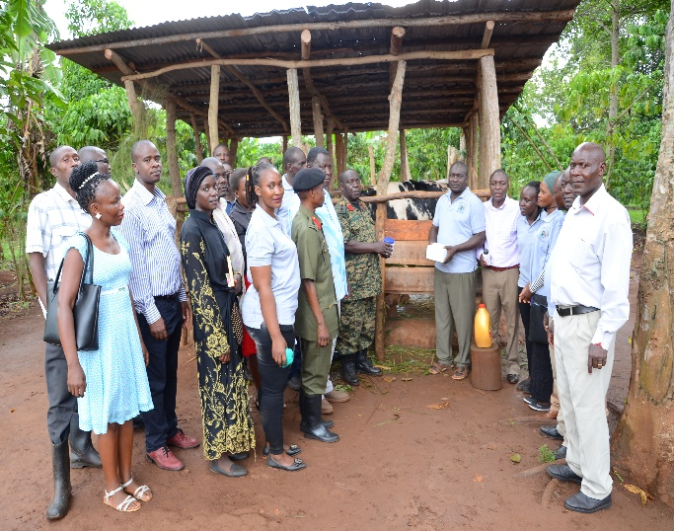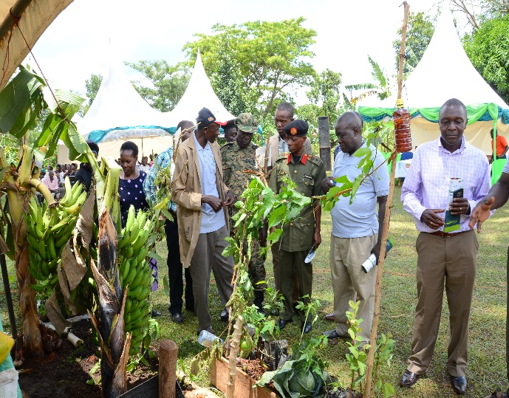
- Launching 4-acre model concept in Kimenyedde sub county
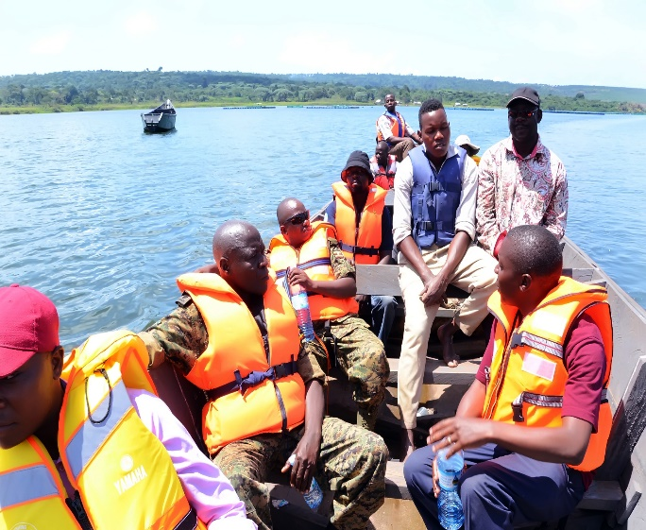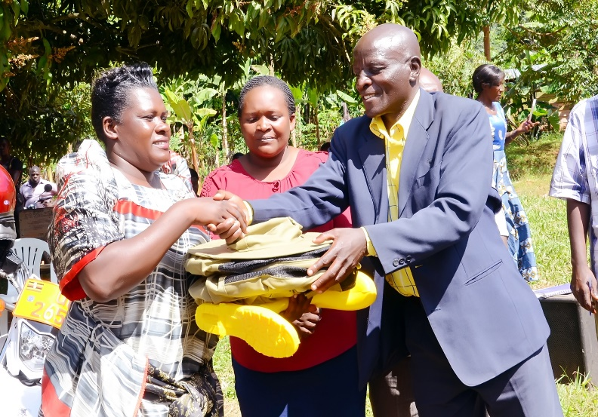
- Launching 4-acre model concept in Koome Island sub county

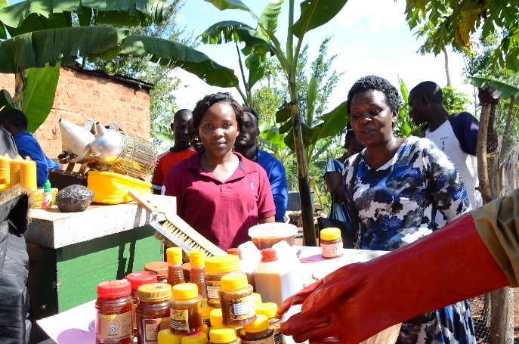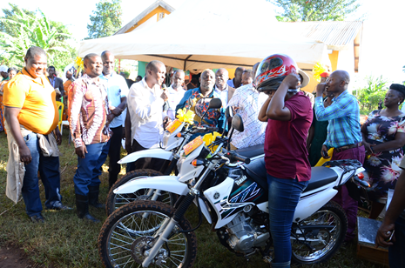
C) Launching 4-acre model concept in Nama Sub County

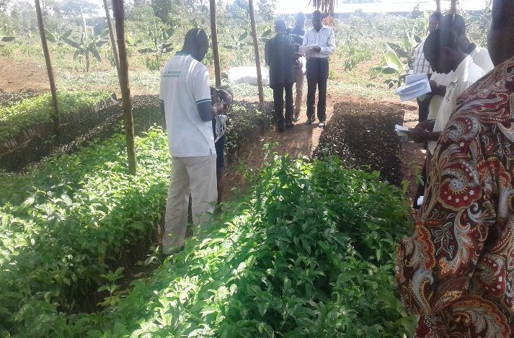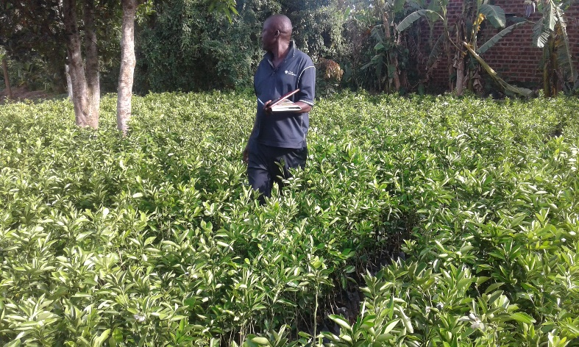
e) Inspection and certification of Fruit Tree Nurseries in Mukono district
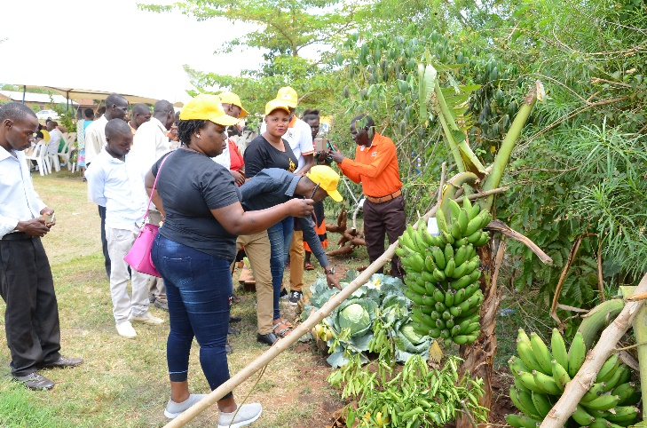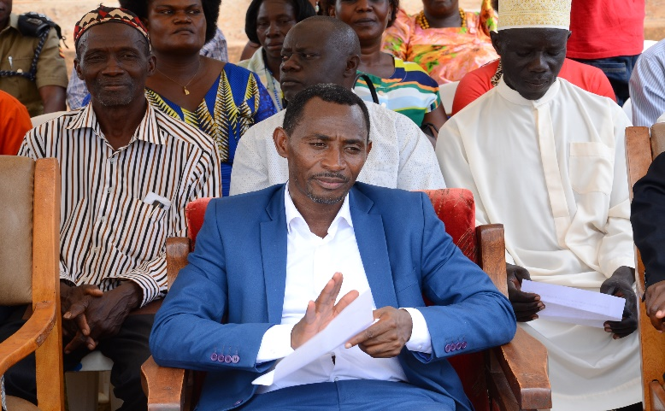
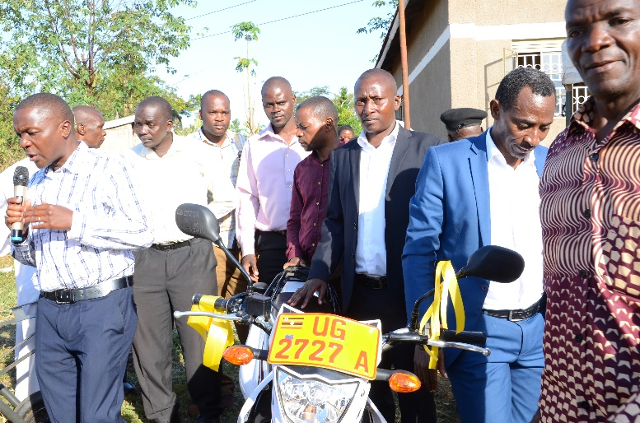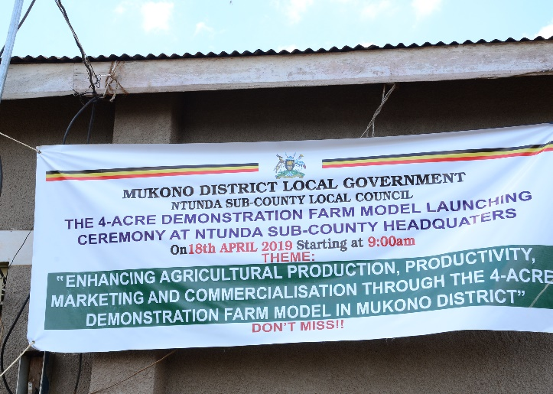

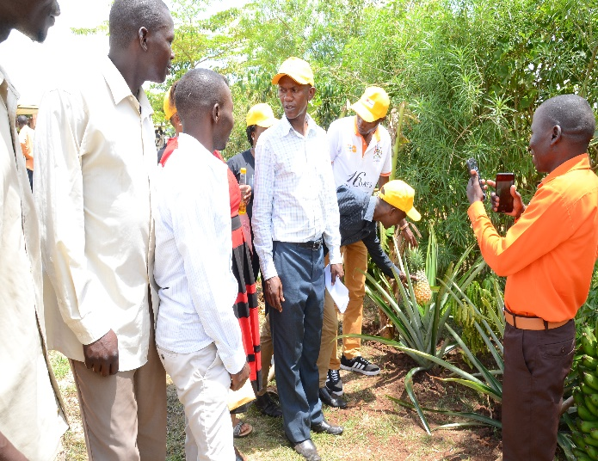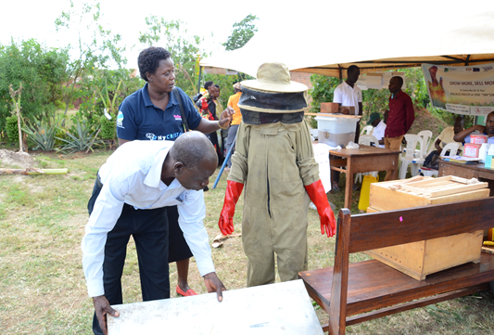
f) Launching 4-acre model in Ntunda sub county Mukono district

TRADE, INDUSTRY AND ECONOMIC DEVELOPMENT

Mandate. This department is mandated with promotion and development of Local economic Development, Trade and Investment, Cooperatives, Tourism Services, Market Linkages and Industrialization. During Financial Year 2018/2019, this department was a sector under Production and Marketing Department and it was upgraded into a department with effect from Financial Year 2019/20

3.9.1 Department Priorities for 2019/20 FY
- Training and sensitizing 200 entrepreneurs about trade License and the importance of registering their businesses.
- Training and registering 36 new cooperative societies
- Formation of at least 3 Area cooperative Enterprises in three different sub counties
- Assessment of 80 businesses in regard to conformity to laws and policies
- Provision of guidance to 12 Small and Medium Enterprises to acquire a standard mark

3.9.2 Achievements in Quarter one for 2019/20 FY
- Trained 6 Youth groups in financial literacy and best practices of business management
- Registered 22 Cooperative societies
- Sensitized District Technical planning committee in Local Economic development

NATURAL RESOURCES DEPARTMENT

Mandate. The Production department has a mandate of ensuring sustainable management and utilization of district natural resources. During Financial Year 2018/2019, Natural Resources department registered the following achievements:

- The department distributed 30,000 seedlings of Prunus africana from CUDWELL industries Tree nursery to SCs of Mpatta, Nakisunga, Kyampisi, Kasawo, Kimenyedde and Ntenjeru SCs (over 30 House Hold s)
- Carried out monitoring of the planted tree seedlings in Nagojje SC by district committee.
- Carried out inspection of forest owners and tree planters in Koome SC and in the lake shore Sub counties.
- Monitored roads maintenance for compliance to environmental and social impacts mitigation in Ntenjeru, Mpatta, Mpunge, Ntunda and Namuganga
- Monitored Constructions of OPD at Kasawo HCIII, latrine construction at Ddamba Health center II in Koome SC for compliance to Environment and social impacts mitigation measures
- The Department Certified on the completed project at Kayini-Kamwokya Ps ( Construction of 2 classroom block, office, store and supply of furniture for the two classrooms
- The department carried out sensitization on wetland management and general environment management for key stakeholders particularly local communities on RADIO DUNAMIS.
- Carried out training of local political leaders in Nagojje and Kyampisi SCs on their roles and responsibilities regarding Environment and wetland management (Policies, legislations and guidelines)
- The Department approved 398 Building plans.
- The department conducted 4 sensitization meetings in Ntunda and Nagojje for participatory assessment degradation of ecosystems, need to restore them and Action planning for restoration activities
- The department also conducted 4 inspection visits in Ntunda and Nagojje SCs for assessment of degradation of wetlands there in
- The department conducted 33 schools inspected for environmental compliance for licensing and registration
- The department screened 5 district level projects for environmental and social impacts; mitigation measures identified and incorporated in Bid documents for implementation by contractors in Nagojje, Namuganga, Kimenyedde, Koome SCs.
- The department screened 4 projects for mitigation measures under Works department where they use force on accounts in the following lower local governments Mpunge, Ntenjeru, Mpatta, Nagojje, Seeta Namuganga .

3.10.1 Department Priorities for 2019/20 FY
- Procurement of 30000 Tree seedlings for planting in Primary and Secondary schools in lower local governments
- Conducting Sensitization and training seminars on Climate change issues for sub-county councils
- Conducting Environment Impact Assessment of development projects in different local governments.
- Appraising 10 technical proposals on environment regarding environment audit, impact assessment and sustainability.
- Carrying out community sensitization on physical planning and land use management.

3.10.2 Achievements in Quarter one for 2019/20 FY
- Continuation of undertaking the physical development planning of Katosi TC and now stands at 80% completion.
- Initiated the physical development planning of Ntenjeru-Kisoga TC and so far 20% of the activities undertaken. Boundary maps for administrative units(parishes and villages) produced
- Approval of Building plans (75 plans) and UGX 65m realized at SC level.
- Collection of Plan consent fees at UGX 4.5m realized.
- Inspection of building sites prior to recommendations to establish compliance to standards and guidelines. 60 field visits undertaken.
- Routine monitoring of 9 development sites of private developers against compliance to environmental laws, guidelines and standards.
- Production and Natural resources Committee monitoring of the lake shores and wetlands in Katosi TC
- Training and mentoring of Local environment and natural resources (SC, Parish and village levels) on their roles and mandates in the implementation of the policies, legislations, guidelines and standards as per the amended National Environment Act, 2019.

3.10.3 Department Challenges
- Over reliance of the rural population on natural resource base hence over exploiting them especially youths
- Inadequate funding and facilitation to the department and exclusive reliance on locally generated revenue which constitutes less than 5% of the district entire budget.
- Slow compliance of sub counties towards physical planning regulations.

COMMUNITY BASED DEPARTMENT

Mandate. The Community Based Department has a mandate of empowering communities to harness their potential through skills development, cultural growth and labor productivity for sustainable and gender responsive development. During Financial Year 2018/2019, Community based department registered the following achievements:
- A total of 414,570,000/= was advanced to 51 youths groups to undertake different projects as per the attachment. A total of 586 youths were beneficiaries under YLP(Youth Livelihood Programme
- A total of 09 women groups were advanced 74,300,000/= to undertake different projects under UWEP (Uganda Entrepreneurship Programme).So far 31,338,475/= (36%) has already been recovered by June 2019.
- Conducted verification and assessment of groups to access both YLP and UWEP funds in all the sub counties and town councils.
- Registered groups to enable them open bank accounts as part of the prerequisite to access YLP and UWEP funds.
- Mobilization and formation of CBOs (Community Based Organizations). A total of 365 groups were registered while 139 CBOs were renewed.
- Monitored all YLP groups
- Carried out identification, assessment and referral of PWDS (People with Disabilities) who need further management.
- Disbursed 17,000,000/= to 16 PWD groups under Special Grant funding for disability.
- Carried out enforcement of YLP funds recovery from the defaulting youth groups.
- Registered and handled 293 labour cases between employers and employees.
- Carried out workplace inspections in 40 workplaces on occupational safety and health.
- Carried out sensitization on industrial relations in 73 workplaces
- Registered and handled 105 workers compensation cases
- Successfully celebrated Women’s day on 27th march 2019 at the District head quarters
- Successfully celebrated Labour Day in conjunction with Mukono Municipality on 7th June 2019.
- Held 2 District Women Executive Meetings and 01 District Women Council.
- A total of 560 welfare cases handled (48 males 512 females)
- A total of 25 youths (15 male and 10 females) were referred to UYDEL (Uganda Youth Deployment Link) for skills training.
- A total of 911 needy children (461females and 450 males) are being cared for under children’s homes with Noarh’s Ark taking a lead.

3.11.2 Department Priorities for 2019/20 FY
- Mainstreaming gender in all sector activities, projects and programmes
- Carrying out enforcement of YLP funds recovery from the defaulting youth groups
- Conducting verification and assessment of groups to access both UWEP funds in all the sub counties and town councils.
- Carrying out registration of groups to enable the open bank accounts as part of the prerequisite to access UWEP funds.
- Mobilization and formation of CBOs (Community Based Organizations). This involves registration of new groups as well as renewal of the old ones.
- Monitor all groups under Youth Livelihood Programme and Uganda Women Entrepreneurship Programme.
- Community mobilization and empowerment
- Carrying out workplace inspections in workplaces on occupational safety and health.
- Carrying out sensitization on industrial relations in workplaces
- Celebration the national days that fall under the sector: Women’s day, Youth Day, Labour Day, Day of Older Persons, Day of People with Disabilities, Day of African Child, Literacy day
- Holding mandatory District Women Executive Meetings and District Youth Executive meetings as well as District Youth and District Women Council.

3.11.3 Achievements in Quarter one for 2019/20 FY
- The major activity undertaken was technical monitoring of YLP and UWEP in the following sub counties: Nama, Mpatta, Ntenjeru-Kisoga T/C, Katosi T/C, Kyampisi, and Nakifuma –Nagalama TC. The technical monitoring team was composed of the following: Deputy Chief Administrative Officer (DCAO), District Community Development Officer (DCDO), Senior Community Development Officer (SCDO), Uganda Women Entrepreneurship Programme (UWEP) Focal Person as well as the respective Sub County Community Development Officers (CDOs) and technocrats.
- The department recovered a total of 10,600,200/= (Ten million, six hundred thousand two hundred shillings) under YLP (Youth Livelihood Programme) and remitted it to BOU (Bank of Uganda)
- The department with guidance from District Technical Planning Committee assessed and approved 22 UWEP groups for funding with a total amount of Ugx 220,237,250/= and forwarded them to the Ministry of Gender Labour and Social Development for funding.
Table 8: UWEP Approved Groups for Funding
No | Sub County | Parish | Name of the  Group | Project/  Enterprise | No. of members in the Group | Amount  Requested | Amount  Approved
01 | Nama | Nama | Mukisa Women  Development  Group | Piggery | 10 | 6.730.000 | 9.000.000
02 | Nama | Mpoma | Kukiriza  Women’s Group  Association | Tents &Chair |  | 9.000.000 | 9.000.000
03 | Kyampisi | Kabembe | Tuzukuke  Kiyunga Group | Catering Service | 15 | 12.000.000 | 12.000.000
04 | Kimenyedde | Kawongo | Business/Whole  sale | Business/Whole  sale | 12 | 12.500.000 | 12.500.000
05 | Kimenyedde | Kawongo | Mukago Group | Sugarcane  Growing | 11 | 6.000.000 | 6.000.000
06 | Kimenyedde | Kawongo | Bakyala Tukole  Women’s Group | Tents & Chair | 11 | 12.500.000 | 12.500.000
07 | Koome | Lwomolo | Twezimbe  Development  Group | Rice Growing | 10 | 8.124.000 | 8.124.000
08 | Koome | Busanga | Akwata Empola  Women’s Group | Fish Trade | 10 | 12.000.000 | 12.000.000
09 | Mpatta | Nakalanda | Kisoboka  Women’s Group | Piggery | 10 | 8.095.000 | 8.095.000
10 | Mpatta | Mubanda | Lweza Women’s  Group | Piggery | 10 | 8.095.000 | 8.095.000
11 | Katosi Town  Council | Katosi | Katosi Mukenne  Fishers and Processors Association | Fishing and  Value | 12 | 12.500.000 | 12.500.000
12 | Kasawo | Kabimbiri | Blessed Women  Kabimbiri | Poultry | 15 | 12.443.250 | 12.443.250
13 | Kasawo | Kakukuru | Zibula Atude  Kizanyirizi  Group | Sugarcane  Growing | 15 | 12.500.000 | 12.500.000
14 | Nakifuma/Na  galama T/C | Nagalama | Twekulakulanye  Women’s Group | Produce .Buying  and Selling |  | 7.150.000 | 7.150.000
15 | Nakifuma/Na  galama T/C | Bamusuta | Tukolerewamu  Women Group | Produce buying  and selling | 15 | 5.330.000 | 5.330.000
16 | Nakifuma/Na  galama T/C | Nakanyon  yi | Tewali Kilema  Mukama Group | Horticulture and  Vegetable | 10 | 5.000.000 | 5.000.000

No | Sub County | Parish | Name of the  Group | Project/  Enterprise | No. of members in the Group | Amount  Requested | Amount  Approved
 |  |  |  | Growing
17 | Ntenjeru/Kisoga T/C | Bugoye | Afaayo  Production and Marketing Group | Piggery | 15 | 12.000.000 | 12.000.000
18 | Ntenjeru/Kisoga T/C | Ssayi | Bwakedde  Mpulira Widows  Group | Piggery | 11 | 12.5000.000 | 12.500.000
19 | Nagojje | Waggala | Kasozi Women’s Group | Sugarcane  Growing | 10 | 10.200.000 | 10.200.000
20 | Nakisunga | Wankoba | Tokolerewamu  Women’s Group | Piggery | 13 | 10.000.000 | 10.000.000
21 | Nakisunga | Kiyoola | Kiyoola Women’s Group | Shoe making | 13 | 12.500.000 | 12.500.000
22 | Mpunge | Mpunge | Nezikokolima  Women’s Group | Tents & Chair | 15 | 11.300.000 | 11.300.000
 |  |  |  |  |  | TOTAL | 220,237,250

3.11.3 Department Challenges

- Execution of the CBS mandate has shifted from the mainstream department of CBS to the Civil Society Organization as “autonomous entities” by the donor community. Tracking ownership and sustainability of such programmes is rather hard.
- The rigorous process of registering the NGOs with the NGO Board has led to an influx of organizations opting to register as CBOs yet their structure and activity description qualify them to be NGOs.
- Harmonizing the labour laws, investments and job scarcity. This has made it difficult to enforce the labour laws.
- The issue of children Homes where the homes are not registered and yet the dilemma is where to relocate the children once the home is closed
- Communities lack vital information on on-going and planned government sector development programmes and services in place. This is largely due to apathy among the community members. This has resulted into community indifference and poor responses to various sector interventions at community level.
- Community Ownership of on-going development interventions in Local Governments is still inadequate. The beneficiaries’ consider the projects/programmes as owned by the specific initiators or government to which they feel should take full responsibility. As such they neglect the operation and maintenance requirements.
- The above is coupled with the dependence syndrome where beneficiaries still run to the initiators of the programmes in case of any eventuality.
- Non-tangibility results of Social Development Sector. Tangibility of results has become the basis for funds allocation which puts CBS at a disadvantage

Mr. Speaker Sir, Council and Statutory Bodies is comprised of the following key Sector names:- Under District Council, Standing Committees of Council,District Executive ,Local Government Public Accounts Committee, District Service Commission and District Land Board .Below are the key achievements which were attained during Financial Year 2018/19.
- The District Council convened five times where it approved motions on budget and procurement among others.
- Standing Committees of Council convened 5 times where they discussed sector reports, work plan and budgets.
- The District Executive committee carried out its mandate through holding 15 meetings to exercise its mandate as highlighted under the law.
- The District Executive committee carried out monitoring of government projects in Kyampisi, Nama, Koome, Namuganga, Nakisunga, Mpunge, Mpatta, Kasawo, Nagojje, Kimenyedde, and Ntunda sub-counties.
- Paid Councillors' Exgratia for the 4 quarters in FY 18/19
- The District land board meetings were held to consider land applications
- The Local government Public Accounts Committee convened to examine the Municipal, Town Councils, sub-counties and District Headquarter Internal Audit reports
- 28 C Procurement meetings held
- Paid LC III Honoraria and Exgratia for LCI and LCII

Mr. Speaker Sir, deliverance of services to the people of Mukono District encountered some many challenges that have been highlighted above in different sectors. The district executive developed the following recommendations to address the service delivery challenges as indicated below:

- There is need for the Heads of departments to resort to development of proposal writing as an alternative way of resource mobilization.
- Finance and Planning department, Administration, Works and Water departments should plan and budget for the purchase of vehicles to facilitate departmental activities in the third Five Year Development Plan.
- There is need for the District Council to lobby Central government to increase on the teacher staff ceiling.
- The department of Natural Resources should increase its vigilance in lower local governments to ensure that sand mining activity is a regulated.
- The leaders, at all levels, should sensitize the public on the dangers of blocking runoff water from the roads.
- There is need for Lower Local Governments to come up with by-laws that prohibit trucks from overloading.
- There is need for Education department to organize Continuous Professional Development (CPDS) for teachers and Head teachers.
- There is need for Education department to intensify Inspection and Supervision of Schools at all levels.
- There is need for the district council to lobby for extra funding from Central government and Private Partners in Education development

Attachment 1: Youth Livelihood Programme Beneficiaries (YLP) 2018/2019
S/N | COUNTY/ Municipality | SUB COUNTY | PARISH | VILLAGE | Group Name | PROJECT NAME | No of Beneficiaries |  |  | AMOUNT APPROVED (SHS)
 |  |  |  |  |  |  | M | F | Total
1 | Mukono | Katosi Town council | Bunakijja | Golomoro | Golomoro Youth Piggery | Piggery Farming | 6 | 4 | 10 | 6,320,000
2 | Mukono | Nama | Katoogo | Waluga | Waluga Makula Youth Piggery | Piggery Farming | 4 | 6 | 10 | 7,140,000
3 | Nakifuma | Nakifuma – Naggalama | Naggalama | Naggalama Town | Naggalama Town Adams Youth Salon | Saloon | 2 | 8 | 10 | 7,890,000
4 | Mukono | Nama | Katoogo | Waluga | Waluga Youth Briquettes | Briquettes | 7 | 3 | 10 | 5,000,000
5 | Nakifuma | Nakifuma – Naggalama | Bamusuta | Busaabala | Busaabala Youth Stationery Traders | Stationery | 7 | 3 | 10 | 7,000,000
6 | Mukono | Katosi Town council | Katosi | Kizaala Buganda | Kizaala Youth Boda Boda | Bodaboda | 7 | 3 | 10 | 8,500,000
7 | Nakifuma | Nakifuma – Naggalama | Nabalanga | Nabalanga | Nabalanga Youth Produce Traders | Produce buying and selling | 4 | 6 | 10 | 7,000,000
8 | Mukono | Mpatta | Kiyanja | Kiyanja | Kiyanja Youth Tailoring and Designers | Tailoring and Designing | 6 | 5 | 11 | 12,470,000
9 | Nakifuma | Ntunda | Namayuba | Namayuba | Namayuba Youth Cavendish Apple Banana Growers | Cavendish Banana Growing | 4 | 6 | 10 | 7,000,000
10 | Nakifuma | Ntunda | Kyabazaala | Kyabazaala | Kyabazaala Sisimuka Youth Soft Drinks wholesalers | Beer Depot | 3 | 7 | 10 | 7,000,000
11 | Mukono | Mpunge | Mbazzi | Sango | Sango Youth Boda Boda | Bodaboda | 7 | 8 | 15 | 8,940,000
12 | Mukono | Katosi Town council | Katosi Ward | Katosi Central | Katosi Central Youth Auto Boat operators | Engine Mainenence | 7 | 3 | 10 | 11,000,000
13 | Nakifuma | Ntunda | Kateete | Kateete | Kateete Sikyomu Youth Apple Banana Growers | Cavendish (Apple) Banana Growing | 7 | 3 | 10 | 7,000,000
14 | Nakifuma | Ntunda | Ntunda | Ntunda | Ntunda Youth Metal Fabricators | Metal Fabrication and Welding | 6 | 4 | 10 | 8,000,000
15 | Mukono | Katosi Town council | Katosi | Kizaala Buganda | Kizaala Katosi Youth Boat Builders | Boat building and maintenance | 6 | 4 | 10 | 9,000,000
16 | Mukono | Koome | Bugombe | Bugombe | Bugombe Mwoyo gumu Youth Boda Boda | Boda Bodas | 6 | 4 | 10 | 12,500,000
17 | Mukono | Koome | Lwomolo | Nkakwa | Nkakwa Munnaku Kama Youth Rice Growers | Rice Growing | 7 | 3 | 10 | 8,124,000
18 | Mukono | Nama | Katoogo | Samuuka | Samuuka St. Charles Lwanga Youth Tomato Growers | Tomato growing | 7 | 4 | 11 | 5,260,000
19 | Mukono | Seeta Namuganga | Kitula | Kitula | Kitula Kikonyogo Youth Rice Growers | Rice Growing | 8 | 4 | 12 | 9,370,000
20 | Mukono | Seeta Namuganga | Kitale | Kitale B | Kitale B Agali Awamu Youth Produce Traders | Produce buying and selling | 6 | 7 | 13 | 7,000,000
21 | Mukono | Ntenjeru – Kisoga | Kisoga | Kisoga Central | Kisoga Central Youth Tents and Chairs | Tents and Chairs | 5 | 6 | 11 | 9,860,000
22 | Mukono | Ntenjeru – Kisoga | Ntenjeru Ntanzi | Kito Kiganda | Kito Kiganda Liberty Youth Piggery | Piggery Farming | 6 | 4 | 10 | 7,000,000
23 | Mukono | Ntenjeru – Kisoga | Terere | Bunankanda | Bunankanda Trust youth Piggery | Piggery Farming | 7 | 3 | 10 | 7,980,000
24 | Mukono | Ntenjeru – Kisoga | Ssayi | Kalagala | Kalagala Bajja Basaaga Youth Piggery | Piggery Farming | 6 | 4 | 10 | 7,000,000
25 | Mukono | Seeta Namuganga | Namanoga | Nakasejjere | Nakasejjere Twezimbe Youth Millers | Maize Mill | 7 | 4 | 11 | 8,500,000
26 | Nakifuma | Nakifuma - Naggalama | Nakanyonyi | Nakanyonyi | Nakanyonyi Youth Coffee Nursery | Coffee Nursery Bed | 6 | 4 | 10 | 7,000,000
27 | Nakifuma | Nakifuma - Naggalama | Naggalaama A | Kalagi | Kalagi Mutindo Youth metal fabricators | Welding and Metal Fabrication | 7 | 3 | 10 | 8,000,000
28 | Nakifuma | Nakifuma - Naggalama | Bubiro | Bubiro | Bubiro Nakifuma Youth bakers | Bakery | 5 | 5 | 10 | 9,500,000
29 | Mukono | Seeta Namuganga | Kayini | Kikoma | Kikoma Kyusa Ekitundukyo Youth Piggery | Piggery Farming | 6 | 6 | 12 | 7,000,000
30 | Mukono | Nakisunga | Namuyenje | Kyawambogo | Kyawambogo Vision 2040 youth Millers | Maize Mill | 6 | 4 | 10 | 10,000,000
31 | Mukono | Nama | Bulika | Lutengo B | Lutengo B Youth Metal Fabricators | Metal Fabrication and Welding | 9 | 6 | 15 | 7,000,000
32 | Mukono | Nama | Namawojjolo | Namawojjolo West | Namawojjolo Youth Welders | Metal Fabrication and Welding | 7 | 3 | 10 | 7,880,000
33 | Mukono | Nama | Namubiru | Takajunge | Takajunge Youth crafts and embroidery | Crafts and Embroidery | 1 | 10 | 11 | 6,810,000
34 | Mukono | Kyampisi | Ddundu | Ddundu | Ddundu Youth Nursery Bed | Nursery Bed | 10 | 5 | 15 | 7,000,000
35 | Mukono | Kyampisi | Bulijjo | Naalya | Naalya Bulijjo Youth Poultry | Exotic Poultry | 7 | 4 | 11 | 8,250,000
36 | Mukono | Kyampisi | Ntonto | Kwaba | Kwaba Youth Poultry | Exotic Poultry | 6 | 4 | 10 | 7,000,000
37 | Nakifuma | Seeta Namuganga | Namuganga | Nsajji | Nsajji United Youth Tents and Chairs | Tents and Chairs | 3 | 7 | 10 | 9,860,000
38 | Nakifuma | Kasawo | Kitovu | Kasawo | Kasawo Youth coffee traders | Coffe Buying and Selling | 7 | 3 | 10 | 7,500,000
39 | Nakifuma | Kasawo | Kitovu | Kasawo | Kasawo Afaayo Brave Youth Metal Fabrication | Metal Fabrication and Welding | 7 | 3 | 10 | 7,000,000
40 | Nakifuma | Kasawo | Namaliri | Gavu | Gavu Bibalabulamu Youth Nursery | Mango nursery Bed | 7 | 3 | 10 | 7,000,000
41 | Nakifuma | Kasawo | Namaliri | Gavu | Gavu Bivamuntuyo Youth concrete products | Concrete Brick making project | 7 | 3 | 10 | 7,500,000
42 | Nakifuma | Kasawo | Kitovu | Kasawo | Kasawo Youth stationery Traders | Stationery | 7 | 4 | 11 | 8,000,000
43 | Nakifuma | Kasawo | Kabimbiri | Kabimbiri Central Zone | Kabimbiri Central Kyonna Youth tomatoes growers | Tomato growing | 7 | 3 | 10 | 8,000,000
44 | Mukono | Mpunge | Ngombere | Ngombere | Ngombere Youth Piggery | Piggery Farming | 2 | 10 | 12 | 7,000,000
45 | Mukono | Mpunge | Mpunge | Masujju | Massujju Youth Piggery | Piggery Farming | 7 | 5 | 13 | 7,000,000
46 | Mukono | Mpunge | Ngombere | Buwujja | Buwujja Youth Boda Boda | Bodaboda | 5 | 9 | 14 | 8,940,000
47 | Nakifuma | Kimenyedde | Kiwafu | Kimenyedde | Kimenyedde Youth Boda Boda | Bodaboda | 7 | 3 | 10 | 12,500,000
48 | Nakifuma | Kimenye  Dde | Kiwafu | Nabukuku | Nabukuku Bivamuntuyo Youth Poultry | Exotic Poultry | 7 | 3 | 10 | 7,180,000
49 | Mukono | Mpatta | Mpatta | Mpatta | Mpatta Destiny Youth Fabrication | Welding and Metal Fabrication | 6 | 4 | 10 | 8,000,000
50 | Mukono | Mpatta | Mugomba | Bugigi | Bugigi youth Piggery | Piggery Farming | 9 | 5 | 14 | 8,100,000
51 | Mukono | Katosi Town council | Katosi Ward | Katosi central | Katosi Central Trinity Youth Electronics | Electronics | 3 | 7 | 10 | 8,000,000

Attachment 2: Uganda Women Entrepreneurship Programme Beneficiaries (UWEP) 2018/2019

SN | NAME OF GROUP | SUB-COUNTY | PARISH/VILLAGE | ENTERPRISE | CONTACTS | AMOUNT APPROVED
1 | Nezikokolima Development Group | Mpatta | Mpatta J/Mpatta | Piggery | 0774-937385  0789-712293 | 6.000.000
2 | Akwata Empola Tailoring group | Kimenyedde | Namaliga /  Nakifuma west | Tailoring and Design |  | 6.500.000
3 | Lufunve Branch Development Group | Nakisunga | Kyetume /Lufunve | Tents and Chairs | 0701-970492 | 12.400.000
4 | Abafuba Women’s Development Group | Seeta Namuganga | Kayini /Bwegire | Poultry/  Layers | 0782352341 | 6.400.000
5 | Bwavu Mpologoma Development Group | Nagojje | Nagojje Maganda | Tents & chairs | 0754523203  0750666402 | 10.200.000
6 | Kayanja Women’s Development initiative | Nagojje | Namagunga /  Kayanja | Catering services | 0751- 658005  0775-396769 | 12.500.000
7 | Muzzanganda Women’s Group | Kasawo | Kasana /Kiyigi | Tents& Chairs | 0782-952122  0774-517983 | 10.000.000
8 | Twekolere Women’s Farmers Group | Kasawo | Kigogola /Katete | Piggery | 0782952122  0774-517983 | 5.000.000
9 | Alarms Foundation | Nama | Namawojjolo /  Namawojjolo west | Tailoring |  | 5.300.000
 |  |  |  | TOTAL |  | 74,300,000

